Romanian Ministry of Development, Public Works and Administration

Managing Authority

(INTERREG VI-B) NEXT Black Sea Basin Programme

GUIDELINES FOR GRANT APPLICANTS
Reference: Call for Proposals

SMALL SCALE PROJECTS

PART I

KEY ASPECTS OF THE (INTERREG VI-B) NEXT
BLACK SEA BASIN PROGRAMME

GLOSSARY OF ABBREVIATIONS

BSB Black Sea Basin
BSS Black Sea Synergy
CMA Common Maritime Agenda
EC European Commission
EUSDR European Union Strategy for the Danube Region
EUSAIR European Union Strategy for the Adriatic and Ionian Region
ISO Interreg Specific Objective
JEMS Joint Electronic Monitoring System
JS Joint Secretariat
LP Lead Partner
MA Managing Authority
MC Monitoring Committee
MS Member States
NUTS Nomenclature of Units for Territorial Statistics
NUTS 2 Second level of divisions created for statistical purposes
PO Policy Objective
SO Specific Objective
SRIA Strategic Research and Innovation Agenda

Contents
1. LEGAL AND STRATEGIC FRAMEWORK 4
2. OVERVIEW OF INTERREG NEXT BSB PROGRAMME 5
3. ELIGIBLE AREA 5
4. PRIORITIES AND SPECIFIC OBJECTIVES 6
5. BUDGET 12
6. MANAGEMENT STRUCTURES 12
7. LANGUAGE 13

- LEGAL AND STRATEGIC FRAMEWORK

Relevant programme documents
- (Interreg VI-B) NEXT Black Sea Basin Programme;

European Structural and Investment Funds 2021-2027: Key regulations
- Common provisions regulation (CPR) – Regulation (EU) 2021/1060 of the European Parliament and of the Council of 24 June 2021 laying down common provisions on the European Regional Development Fund, the European Social Fund Plus, the Cohesion Fund, the Just Transition Fund and the European Maritime, Fisheries and Aquaculture Fund and financial rules for those and for the Asylum, Migration and Integration Fund, the Internal Security Fund and the Instrument for Financial Support for Border Management and Visa Policy;
- INTERREG Regulation – Regulation (EU) 2021/1059 of the European Parliament and of the Council of 24 June 2021 on specific provisions for the European territorial cooperation goal (Interreg) supported by the European Regional Development Fund and external financing instruments;
- ERDF Regulation - Regulation (EU) 2021/1058 of the European Parliament and of the Council of 24 June 2021 on the European Regional Development Fund and on the Cohesion Fund;
- NDICI Regulation - Regulation (EU) 2021/947 of the European Parliament and of the Council of 9 June 2021 establishing the Neighbourhood, Development and International Cooperation Instrument – Global Europe, amending and repealing Decision No 466/2014/EU and repealing Regulation (EU) 2017/1601 and Council Regulation (EC, Euratom) No 480/2009;
- Financial Regulation (EU, Euratom) 1046/2018 of the European Parliament and of the Council of 18 July 2018 on the financial rules applicable to the general budget of the Union, amending Regulations (EU) No 1296/2013, (EU) No 1301/2013, (EU) No 1303/2013, (EU) No 1304/2013, (EU) No 1309/2013, (EU) No 1316/2013, (EU) No 223/2014, (EU) No 283/2014, and Decision No 541/2014/EU and repealing Regulation (EU, Euratom) No 966/2012;
- Regulation no 2988/1995 on the protection of the European Communities financial interest;

Strategic framework
- Multi-annual strategy document on Interreg NEXT Strategic Programming 2021 - 2027;

Macro-regional strategies
- Common Maritime Agenda for the Black Sea (CMA);
- EU Strategy for the Danube Region (EUSDR), Communication from the Commission to the European Parliament, the Council, the European Economic and Social Committee and the Committee of the Regions - COM(2010) 715 final;
- EU Strategy for the Adriatic and Ionian Region (EUSAIR) Communication from the Commission to the European Parliament, the Council, the European Economic and Social Committee and the Committee of the Regions, COM(2014) 357 final;
- Strategic Research and Innovation Agenda for the Black Sea (SRIA).

- OVERVIEW OF INTERREG NEXT BSB PROGRAMME

The Interreg NEXT BSB Programme is jointly funded by the European Regional Development Fund (ERDF), the Neighbourhood, Development and International Cooperation Instrument (NDICI) and by the Instrument for Pre-accession (IPA), hereinafter referred to as Interreg funds, in the framework of the European Neighbourhood and the Cohesion policy.
The programme was designed so that to ensure continuity and coherence with the Joint Operational Programme Black Sea Basin 2007-2013 and Joint Operational Programme Black Sea Basin 2014-2020 and aims to make use of synergies and complementarities with other EU funded programmes and other donors’ contribution. The programme was agreed by all participating countries following extensive and thorough consultations with relevant partners. The approved version of the Interreg NEXT BSB Programme document is available for download from http://blacksea-cbc.net.

- ELIGIBLE AREA

The programme cooperation area comprises the entire territory or parts (NUTS level 2 or equivalent areas) of the territory of seven countries, of which 3 EU Member States (Bulgaria, Greece, Romania) and 4 partner countries (Georgia, Republic of Moldova, Republic of Türkiye and Ukraine).

The geographical coverage of the Interreg NEXT BSB Programme, as described and reflected in the Programme document, is as follows:
- Bulgaria: Severoiztochen, Yugoiztochen
- Greece: Kentriki Makedonia, Anatoliki Makedonia Thraki
- Romania: Sud-Est
- Republic of Türkiye: TR10 (İstanbul), TR21 (Tekirdağ, Edirne, Kırklareli), TR42 (Kocaeli, Sakarya, Düzce, Bolu, Yalova), TR81 (Zonguldak, Karabük, Bartın), TR82 (Kastamonu, Çankırı, Sinop), TR83 (Samsun, Tokat, Çorum, Amasya) and TR90 (Trabzon, Ordu, Giresun, Rize, Artvin, Gümüşhane)
- Ukraine: Odessa, Mykolaiv, Kherson, Zaporizhzhia Oblasts and Bakhmut District, Kramatorsk District, Volnovakha District, Mariupol District, Pokrovsk District from Donetsk Oblast
- Republic of Moldova, Georgia - whole territory

- PRIORITIES AND SPECIFIC OBJECTIVES

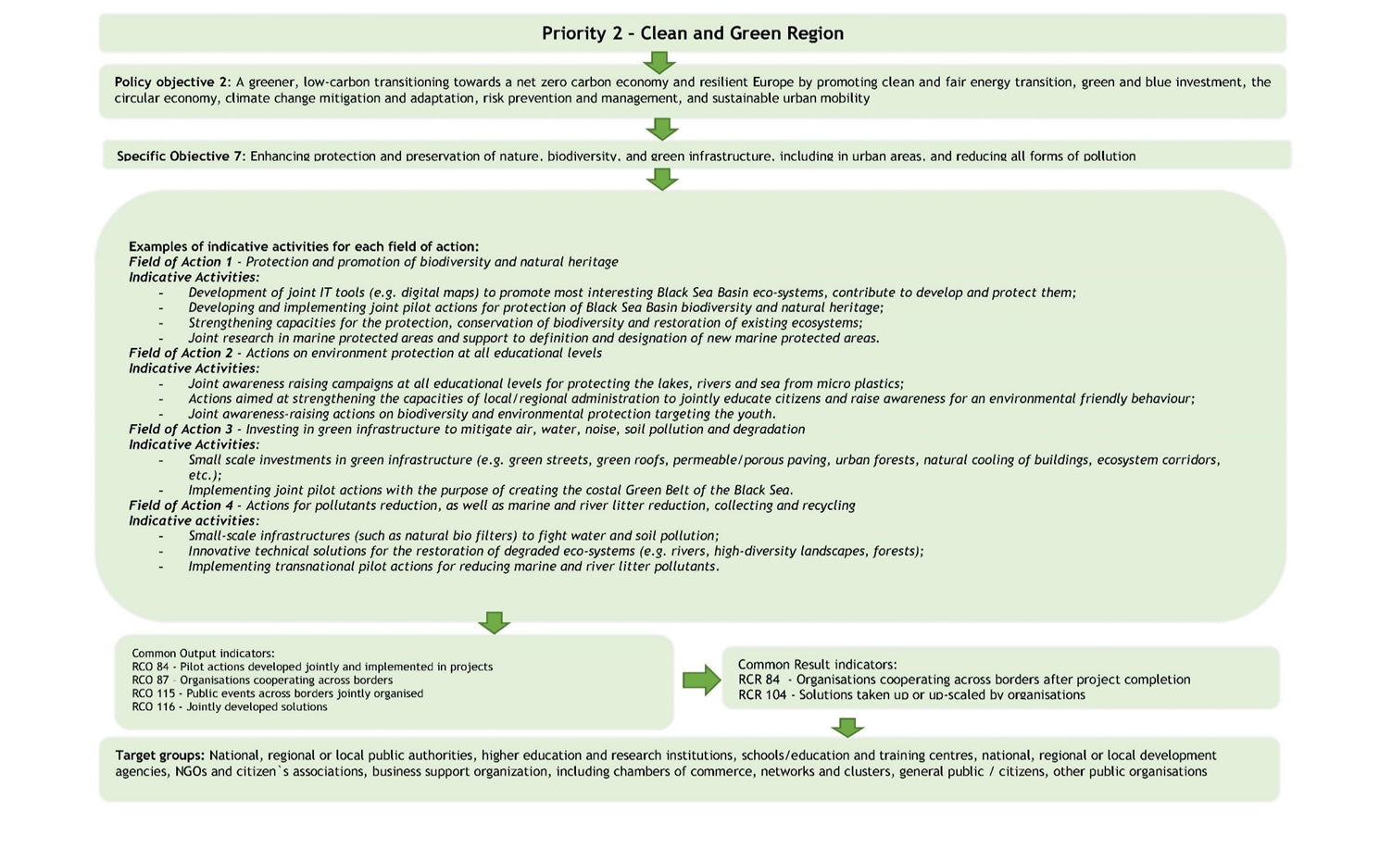
The developed outputs (direct products of supported projects) will be measured by project output indicators, linked to a Programme Common Output Indicator which shall contribute to achieving the programme expected results.

Figure 1- Programme logical framework
Programme
Project
Overall Objective(s)
Results (Specific objectives)
Outputs
Priority (Policy Objective)
Specific Objective
Programme Outputs (Common output indicators)
Activities
Programme Results (Common Result indicators)
Programme suported field of action

The Interreg NEXT BSB Programme will fund projects which clearly demonstrate the translation of outputs into concrete, visible and sustainable results thus contributing to a change of the initial situation with impact on the direct addressee.
All projects will have to define and quantify at least one project output indicator which shall be linked to a relevant Programme Common Output Indicator (RCO) and contribute to a programme specific objective.
Also, all projects shall achieve a set of results that will allow the programme to reach its objectives. Results and related changes are measured through Result indicators (RCR) linked to each programme specific objective.
RCO = Common Output indicator means an indicator to measure the specific deliverables of the intervention, which are the main products, goods, services, obtained following the implementation of project activities with the project funds and that are further used by relevant target groups or final beneficiaries. This indicator is in the control of the project. Indicative examples: tools, small-scale investments, pilot projects/actions, solutions, events, educational products such as training programmes or methods, curricula etc.
RCR = Common Result indicator means an indicator to measure the effects of the interventions supported, with particular reference to the direct addressees, population targeted or users of deliverables. It describes the advantage of carrying out the project. Result(s) are derived from the outputs achieved by the project. Indicative examples: organizations cooperating in the concerned area after project completion, pilot joint actions up-scaled, joint solutions applied, etc.
The Interreg NEXT BSB Programme indicator system is presented below:
Figure 2 – Programme Common Output indicators and result indicators
RCO116 Jointly developed solutions
RCO07 Research organizations participating in joint research
RCO84 Pilot actions developed jointly and implemented in projects
RCO115 Public events across borders jointly organised
RCR84 Organisations cooperating across borders after project completion
RCR104 Solutions taken up or up-scaled by organisations
Common Result Indicators
Common Output Indicators
Priority 1 - BLUE AND SMART REGION
RCO87 Organisations cooperating across borders
RCO116 Jointly developed solutions
RCO84 Pilot actions developed jointly and implemented in projects
RCO115 Public events across borders jointly organised
RCR84 Organisations cooperating across borders after project completion
RCR104 Solutions taken up or up-scaled by organisations
Common Result Indicators
Common Output Indicators
Priority 2 – CLEAN AND GREEN REGION
Specific Objective 4

RCO87 Organisations cooperating across borders

RCO84 Pilot actions developed jointly and implemented in projects
RCO115 Public events across borders jointly organised
RCR84 Organisations cooperating across borders after project completion
Common Result Indicators
Common Output Indicators
Priority 2 – CLEAN AND GREEN REGION
Specific Objective 7
RCR104 Solutions taken up or up-scaled by organisations
RCO87 Organisations cooperating across borders
RCO116 Jointly developed solutions

TAKE NOTE

All projects will contribute to RCO87 - Organisations cooperating across borders
The indicator counts the organisations cooperating formally in supported projects. The organisations counted in this indicator are the legal entities (project partners), as mentioned in the application form.

All applicants are strongly advised to read carefully the Programme Performance Framework Methodology which provides guidance to potential beneficiaries for a coherent approach in the identification of appropriate project indicators able to contribute to Interreg NEXT BSB Programme results and may support beneficiaries during implementation in measuring progress on achieving the proposed targets. The document also explains the most relevant aspects in order to ensure that the project outputs are identified, collected and reported correctly, in line with the programme requirements.

- BUDGET

The Interreg NEXT BSB Programme budget for projects, including co-financing, is of EUR 65,704,670 as in the table below.

Table 1 – Interreg NEXT BSB Programme budget
TOTAL Interreg Funds (EUR)  (90%) | Co-financing  (EUR)  (10%) | TOTAL Programme budget  (EUR)
59,134,203 | 6,570,467 | 65,704,670

- MANAGEMENT STRUCTURES

Managing Authority (MA) - the Romanian Ministry of Development, Public Works and Administration is the responsible body for managing the programme with a view to delivering the objectives of the programme.

National Authority (NA)- entity appointed by each participating country to support the Management Authority in the implementation of the programme in its own territory. The list of the NAs is mentioned in section 7.1 - Programme authorities in the Programme document and can be found on the programme website.

Audit Authority (AA) - within the Court of Accounts of Romania. The main responsibilities of the AA consist of carrying out system audits and audits on operations and on the annual accounts of the programme.
The Audit Authority for the programme is assisted by a Group of Auditors comprising a representative from each country participating in the programme.

Monitoring Committee (MC) - joint decision-making structure for the programme. The MC shall follow the programme implementation and progress in achieving the milestones and targets of the programme and it shall examine any issues affecting the programme performance.

Joint Secretariat (JS) - responsible for fulfilling all the tasks delegated by the MA for the implementation of the Programme – information of potential beneficiaries, support project preparation, evaluation and selection, as well as project implementation. JS for the Interreg NEXT BSB Programme is located in Constanta in the South East Region of Romania within the South East Regional Development Agency (SERDA).

Controllers – the national or regional authority, private body or the natural person identified and appointed by the Contact Point in each participating country to undertake the tasks of management verifications on its territory.

- LANGUAGE

The official language of the Programme is English. Therefore, all communication between applicants (lead partners and/or project partners)/beneficiaries and the MA/JS is carried out in English language. Information in applications, reports as well as official correspondence should be treated accordingly. Although guidance on the Programme might be available in national languages, this can only be used as support when interpreting the Programme rules.

In case translation of documents is needed, it is recommended to take advantage of the Commission automatic translation service, eTranslation covering all EU official languages and part of the languages of the programme eligible area (e.g Turkish and Ukrainian). The tool is available at https://language-tools.ec.europa.eu/

Following the unprovoked and unjustified, unprecedented Russian aggression against Ukraine launched on 24 February 2022 and its impact, only the territories under the control of the sovereign Government of Ukraine are eligible under the programme. Regions currently under Russia’s military control will not be eligible, even if they are part of the Black Sea Basin.
According to the decision of Ukraine submitted in the context of confirmation of the geographical coverage of the programme with a view to prepare the Implementing Act, the following districts from Donetsk are eligible: Bakhmut, Kramatorsk, Volnovakha, Mariupol, Pokrovsk.

